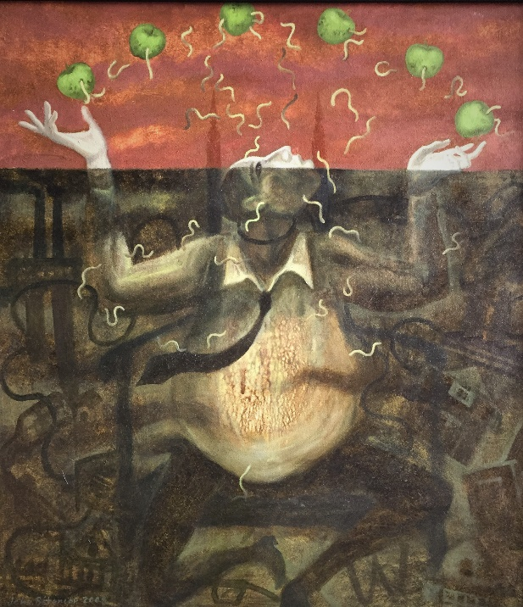

*Jeho Bitancor*

“Hingalo”, 2008.

Oil on canvas mounted on board.

25½” X 28½”

“Hingalo” is Tagalog for “Agony”